## Meeting the Project Criteria

### Project Management Fundamentals

Good project management skills are key to the success of a group project as they ensure that everyone is spending their time and resources effectively. By assigning members roles and setting clear goals, we were able to plan a timeline of the project, which helps make sure everyone knows what they’re doing and that tasks are being divided evenly. The first step to achieve this was to create a gantt chart to give us an outline of when we should have each section complete. A gantt chart is a visual representation of the tasks and timeline of a project that helps to ensure you stay on schedule, making it easy to tell which part of the development stage we should be at by this point.

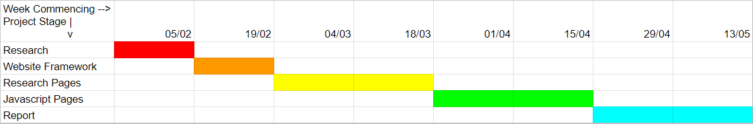

We arranged to meet up once a week to check in on each other's progress and make sure we were all ready to move onto the next stage of development, and to provide each other assistance with their section if required. For example the most common issue we encountered was people having difficulty structuring their HTML and CSS so we would be able to assist each other and make sure that all pages had a consistent style between them. At the end of the meetup sessions we would upload our work to a shared github and make sure that all the files were the latest versions so that we didn’t accidentally overwrite each other’s work with the github merges.

### Working as a team

Part of project management is making sure that the work is divided fairly among the group to each of their specialties. We had three members in our group, one who was skilled at developing code but struggles with writing tasks, another who was the opposite and preferred writing over coding, and a third who had a healthy mix of both categories and no strong preferences either way. This worked out well as it allowed each of us to work on two web pages: the first user worked on the home page and a javascript focused page, the second on two research pages, and the third on a research and a javascript page.

| Name | Strengths | Tasks |
| --- | --- | --- |
| Carlo | Research | Created Github to coordinate and manage the sharing of resources. Designed, researched and developed the online privacy and password security pages. Made the base CSS file for styling on the webpage. |
| Charlotte | Programming | Organised meetups and the project timeline. Designed and developed the home page and password generator. Assisted with HTML/CSS/JS skills and knowledge. |
| Charlie | Balanced |  |

We also made sure to help each other as much as possible in the weekly meetup sessions. Whether that meant pooling together ideas and suggestions for what to include and how to improve the site, assisting each other with their pages structure or issues they were experiencing such as with CSS, or sharing relevant pages and information we found in a shared google drive. Not only did this help ensure work was split evenly, but it improved the site as a whole as each member brought their own perspective and ideas to the project.

## Personal Experiences

### Charlotte

As the most experienced programmer and least skilled at researching and writing essays, I was put in charge of creating the home page and a random password generator, as well as assisting the others with their issues. Another member designed the base CSS that would be used throughout the site including font and colour palette, which I assisted in formatting and finding the correct CSS properties, as I have the technical CSS knowledge but no eye for design so to speak.

The homepage was relatively simple to design. We already had the light and dark blues designed, so I opted to create a section for each of the pages with an alternating colour palette, a brief summary I attempted to keep witty and age relevant, and an appropriate clipart image that matched the text colour of its section. Creating the alternating sections was easy, just a series of <div> tags where every other is given the ‘alt-palette’ class that changes its text and background colour. The most challenging part was finding the appropriate clipart in the right colour, and it ended up being easier to find the most appropriate image and alter the colour myself in photoshop (References to the original images are included in the code comments next to the image).

The password generator was more of a challenge. I based the page on a minigame I found on the NCSC site (reference also included in code comments) that used dice rolls to pick a different part of speech like verbs, nouns, or adjectives, and the user would pick a word from that category. Doing this three times gives you three random unassociated words that can be used as a secure password. I decided to replicate this with a random number generator and a set of word pools that would randomly choose 3 of 5 different parts of speech, before choosing 4 options from the associated pool of words. I wanted to include one of each letter while still keeping the words simple, long enough and memorable to ensure they were appropriate for the target audience, but I had to leave out a few letters as there were no words that met all of those criteria for the group, notably there are no ‘x’ words.

Other than that, I didn’t have many issues developing the code, the biggest challenge I had was how to make sure it didn’t choose repeat words or word pools without removing them from the list so it could be reused. The solution was to have a separate list of chosen values that correlated to the item locations in the arrays, and use a while loop to continuously pick a new value if the chosen value was in the list. The issue with this is that the loop would infinitely repeat on the first attempt as nothing was in the list, so I had to include an invalid value and remove that after the list was fully generated.